**The class diagram**

Extract from:

https://www.ibm.com/developerworks/rational/library/content/RationalEdge/sep04/bell/

The basics

As mentioned earlier, the purpose of the class diagram is to show the types being modeled within the system. In most UML models these types include:

* a class
* an interface
* a data type
* a component.

UML uses a special name for these types: "classifiers." Generally, you can think of a classifier as a class, but technically a classifier is a more general term that refers to the other three types above as well.

Class name

The UML representation of a class is a rectangle containing three compartments stacked vertically, as shown in Figure 1. The top compartment shows the class's name. The middle compartment lists the class's attributes. The bottom compartment lists the class's operations. When drawing a class element on a class diagram, you must use the top compartment, and the bottom two compartments are optional. (The bottom two would be unnecessary on a diagram depicting a higher level of detail in which the purpose is to show only the relationship between the classifiers.) Figure 1 shows an airline flight modeled as a UML class. As we can see, the name is *Flight*, and in the middle compartment we see that the Flight class has three attributes: flightNumber, departureTime, and flightDuration. In the bottom compartment we see that the Flight class has two operations: delayFlight and getArrivalTime.

Figure 1. Figure 1: Class diagram for the class Flight

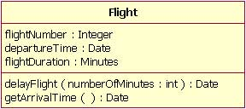

Class attribute list

The attribute section of a class (the middle compartment) lists each of the class's attributes on a separate line. The attribute section is optional, but when used it contains each attribute of the class displayed in a list format. The line uses the following format:

|  |  |
| --- | --- |
| 1 | name : attribute type |
| 1 | flightNumber : Integer |

Continuing with our Flight class example, we can describe the class's attributes with the attribute type information, as shown in Table 1.

Table 1. Table 1: The Flight class's attribute names with their associated types

| **Attribute Name** | **Attribute Type** |
| --- | --- |
| flightNumber | Integer |
| departureTime | Date |
| flightDuration | Minutes |

In business class diagrams, the attribute types usually correspond to units that make sense to the likely readers of the diagram (i.e., minutes, dollars, etc.). However, a class diagram that will be used to generate code needs classes whose attribute types are limited to the types provided by the programming language, or types included in the model that will also be implemented in the system.

Sometimes it is useful to show on a class diagram that a particular attribute has a default value. (For example, in a banking account application a new bank account would start off with a zero balance.) The UML specification allows for the identification of default values in the attribute list section by using the following notation:

|  |  |
| --- | --- |
| 1 | name : attribute type = default value |

For example:

|  |  |
| --- | --- |
| 1 | balance : Dollars = 0 |

Showing a default value for attributes is optional; Figure 2 shows a Bank Account class with an attribute called *balance*, which has a default value of 0.

Figure 2. Figure 2: A Bank Account class diagram showing the balance attribute's value defaulted to zero dollars

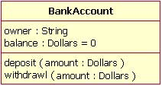

Class operations list

The class's operations are documented in the third (lowest) compartment of the class diagram's rectangle, which again is optional. Like the attributes, the operations of a class are displayed in a list format, with each operation on its own line. Operations are documented using the following notation:

|  |  |
| --- | --- |
| 1 | name(parameter list) : type of value returned |

The Flight class's operations are mapped in Table 2 below.

Table 2. Table 2: Flight class's operations mapped from Figure 3

| **Operation Name** | **Parameters Return** | **Value Type** |
| --- | --- | --- |
| delayFlight | | **Name** | **Type** | | --- | --- | | numberOfMinutes | Minutes | | N/A |
| getArrivalTime | N/A | Date |

Figure 3 shows that the delayFlight operation has one input parameter — numberOfMinutes — of the type Minutes. However, the delayFlight operation does not have a return value. [Note: The delayFlight does not have a return value because I made a design decision not to have one. One could argue that the delay operation should return the new arrival time, and if this were the case, the operation signature would appear as delayFlight(numberOfMinutes : Minutes) : Date.] When an operation has parameters, they are put inside the operation's parentheses; each parameter uses the format "parameter name : parameter type".

Figure 3. Figure 3: The Flight class operations parameters include the optional "in" marking

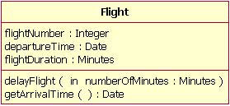

When documenting an operation's parameters, you may use an optional indicator to show whether or not the parameter is input to, or output from, the operation. This optional indicator appears as an "in" or "out" as shown in the operations compartment in Figure 3. Typically, these indicators are unnecessary unless an older programming language such as Fortran will be used, in which case this information can be helpful. However, in C++ and Java, all parameters are "in" parameters and since "in" is the parameter's default type according to the UML specification, most people will leave out the input/output indicators.

Inheritance

A very important concept in object-oriented design, *inheritance*, refers to the ability of one class (child class) to *inherit* the identical functionality of another class (super class), and then add new functionality of its own. (In a very non-technical sense, imagine that I inherited my mother's general musical abilities, but in my family I'm the only one who plays electric guitar.) To model inheritance on a class diagram, a solid line is drawn from the child class (the class inheriting the behavior) with a closed, unfilled arrowhead (or triangle) pointing to the super class. Consider types of bank accounts: Figure 4 shows how both CheckingAccount and SavingsAccount classes inherit from the BankAccount class.

Figure 4. Figure 4: Inheritance is indicated by a solid line with a closed, unfilled arrowhead pointing at the super class

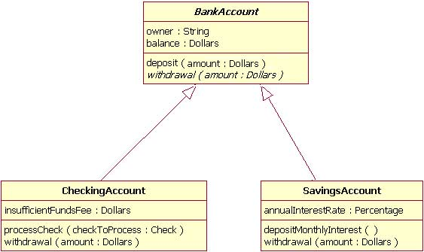

In Figure 4, the inheritance relationship is drawn with separate lines for each subclass, which is the method used in IBM Rational Rose and IBM Rational XDE. However, there is an alternative way to draw inheritance called *tree notation*. You can use tree notation when there are two or more child classes, as in Figure 4, except that the inheritance lines merge together like a tree branch. Figure 5 is a redrawing of the same inheritance shown in Figure 4, but this time using tree notation.

Figure 5. Figure 5: An example of inheritance using tree notation

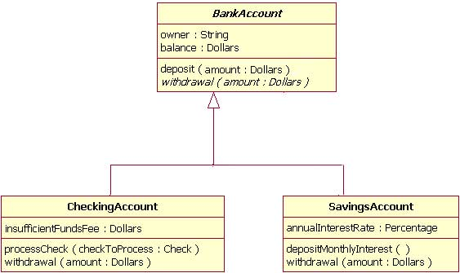

Abstract classes and operations

The observant reader will notice that the diagrams in Figures 4 and 5 use italicized text for the BankAccount class name and withdrawal operation. This indicates that the BankAccount class is an abstract class and the withdrawal method is an abstract operation. In other words, the BankAccount class provides the abstract operation signature of withdrawal and the two child classes of CheckingAccount and SavingsAccount each implement their own version of that operation.

However, super classes (parent classes) do not have to be abstract classes. It is normal for a standard class to be a super class.

Associations

When you model a system, certain objects will be related to each other, and these relationships themselves need to be modeled for clarity. There are five types of associations. I will discuss two of them — bi-directional and uni-directional associations — in this section, and I will discuss the remaining three association types in the *Beyond the basics* section. Please note that a detailed discussion of when to use each type of association is beyond the scope of this article. Instead, I will focus on the purpose of each association type and show how the association is drawn on a class diagram.

Bi-directional (standard) association

An association is a linkage between two classes. Associations are always assumed to be bi-directional; this means that both classes are aware of each other and their relationship, unless you qualify the association as some other type. Going back to our Flight example, Figure 6 shows a standard kind of association between the Flight class and the Plane class.

Figure 6. Figure 6: An example of a bi-directional association between a Flight class and a Plane class

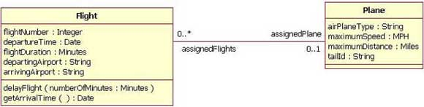

A bi-directional association is indicated by a solid line between the two classes. At either end of the line, you place a role name and a multiplicity value. Figure 6 shows that the Flight is associated with a specific Plane, and the Flight class knows about this association. The Plane takes on the role of "assignedPlane" in this association because the role name next to the Plane class says so. The multiplicity value next to the Plane class of 0..1 means that when an instance of a Flight exists, it can either have one instance of a Plane associated with it or no Planes associated with it (i.e., maybe a plane has not yet been assigned). Figure 6 also shows that a Plane knows about its association with the Flight class. In this association, the Flight takes on the role of "assignedFlights"; the diagram in Figure 6 tells us that the Plane instance can be associated either with no flights (e.g., it's a brand new plane) or with up to an infinite number of flights (e.g., the plane has been in commission for the last five years).

For those wondering what the potential multiplicity values are for the ends of associations, Table 3 below lists some example multiplicity values along with their meanings.

Table 3. Table 3: Multiplicity values and their indicators

| **Indicator** | **Meaning** |
| --- | --- |
| 0..1 | Zero or one |
| 1 | One only |
| 0..* | Zero or more |
| * | Zero or more |
| 1..* | One or more |
| 3 | Three only |
| 0..5 | Zero to Five |
| 5..15 | Five to Fifteen |
| Potential Multiplicity Values | |

Uni-directional association

In a uni-directional association, two classes are related, but only one class knows that the relationship exists. Figure 7 shows an example of an overdrawn accounts report with a uni-directional association.

Figure 7. Figure 7: An example of a uni-directional association: The OverdrawnAccountsReport class knows about the BankAccount class, but the BankAccount class does not know about the association

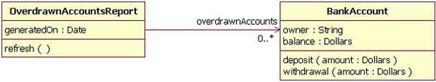

A uni-directional association is drawn as a solid line with an open arrowhead (not the closed arrowhead, or triangle, used to indicate inheritance) pointing to the known class. Like standard associations, the uni-directional association includes a role name and a multiplicity value, but unlike the standard bi-directional association, the uni-directional association only contains the role name and multiplicity value for the known class. In our example in Figure 7, the OverdrawnAccountsReport knows about the BankAccount class, and the BankAccount class plays the role of "overdrawnAccounts." However, unlike a standard association, the BankAccount class has no idea that it is associated with the OverdrawnAccountsReport. [Note: It may seem strange that the BankAccount class does not know about the OverdrawnAccountsReport class. This modeling allows report classes to know about the business class they report, but the business classes do not know they are being reported on. This loosens the coupling of the objects and therefore makes the system more adaptive to changes.]

Packages

Inevitably, if you are modeling a large system or a large area of a business, there will be many different classifiers in your model. Managing all the classes can be a daunting task; therefore, UML provides an organizing element called a *package*. Packages enable modelers to organize the model's classifiers into namespaces, which is sort of like folders in a filing system. Dividing a system into multiple packages makes the system easier to understand, especially if each package represents a specific part of the system. [Note: Packages are great for organizing your model's classes, but it's important to remember that your class diagrams are supposed to easily communicate information about the system being modeled. In cases where your packages have lots of classes, it is better to use multiple topic-specific class diagrams instead of just producing one large class diagram.]

There are two ways of drawing packages on diagrams. There is no rule for determining which notation to use, except to use your personal judgement regarding which is easiest to read for the class diagram you are drawing. Both ways begin with a large rectangle with a smaller rectangle (tab) above its upper left corner, as seen in Figure 8. But the modeler must decide how the package's membership is to be shown, as follows:

* If the modeler decides to show the package's members within the large rectangle, then all those members need to be placed within the rectangle. [Note: It's important to understand that when I say "all those members," I mean only the classes that the current diagram is going to show. A diagram showing a package with contents does not need to show all its contents; it can show a subset of the contained elements according to some criterion, which is not necessarily all the package's classifiers.] Also the package's name needs to be placed in the package's smaller rectangle (as show n in Figure 8).
* If the modeler decides to show the package's members outside the large rectangle then all the members that will be shown on the diagram need to be placed outside the rectangle. To show what classifiers belong to the package, a line is drawn from each classifier to a circle that has a plus sign inside the circle attached to the package (Figure 9).

Figure 8. Figure 8: An example package element that shows its members inside the package's rectangle boundaries

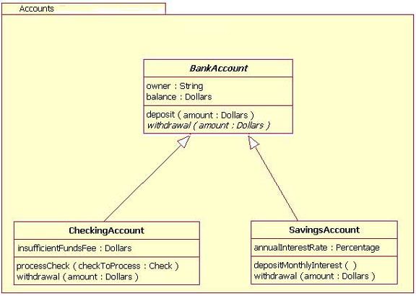

Figure 9. Figure 9: An example package element showing its membership via connected lines

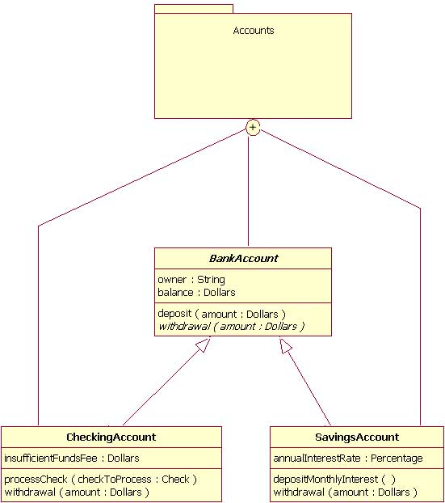

Importance of understanding the basics

It is more important than ever in UML 2 to understand the basics of the class diagram. This is because the class diagram provides the basic building blocks for all other structure diagrams, such as the component or object diagrams (just to name a few).

Beyond the basics

At this point, I have covered the basics of the class diagram, but do not stop reading yet! In the following sections, I will address more important aspects of the class diagram that you can put to good use. These include interfaces, the three remaining types of associations, visibility, and other additions in the UML 2 specification.

Interfaces

Earlier in this article, I suggested that you think of *classifiers* simply as classes. In fact, a classifier is a more general concept, which includes data types and interfaces.

A complete discussion of when and how to use data types and interfaces effectively in a system's structure diagrams is beyond the scope of this article. So why do I mention data types and interfaces here? There are times when you might want to model these classifier types on a structure diagram, and it is important to use the proper notation in doing so, or at least be aware of these classifier types. Drawing these classifiers incorrectly will likely confuse readers of your structure diagram, and the ensuing system will probably not meet requirements.

A class and an interface differ: A class can have an actual instance of its type, whereas an interface must have at least one class to implement it. In UML 2, an interface is considered to be a specialization of a class modeling element. Therefore, an interface is drawn just like a class, but the top compartment of the rectangle also has the text "«interface»", as shown in Figure 10. [Note: When drawing a class diagram it is completely within UML specification to put «class» in the top compartment of the rectangle, as you would with «interface»; however, the UML specification says that placing the "class" text in this compartment is optional, and it should be assumed if «class» is not displayed.]

Figure 10. Figure 10: Example of a class diagram in which the Professor and Student classes implement the Person interface

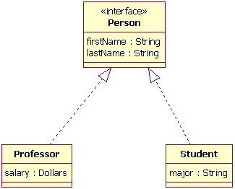

In the diagram shown in Figure 10, both the Professor and Student classes implement the Person interface and do not inherit from it. We know this for two reasons: 1) The Person object is defined as an interface — it has the "«interface»" text in the object's name area, and we see that the Professor and Student objects are *class* objects because they are labeled according to the rules for drawing a class object (there is no additional classification text in their name area). 2) We know inheritance is not being shown here, because the line with the arrow is dotted and not solid. As shown in Figure 10, a *dotted* line with a closed, unfilled arrow means realization (or implementation); as we saw in Figure 4, a *solid* arrow line with a closed, unfilled arrow means inheritance.

More associations

Above, I discussed bi-directional and uni-directional associations. Now I will address the three remaining types of associations.

Association class

In modeling an association, there are times when you need to include another class because it includes valuable information about the relationship. For this you would use an *association class* that you tie to the primary association. An association class is represented like a normal class. The difference is that the association line between the primary classes intersects a dotted line connected to the association class. Figure 11 shows an association class for our airline industry example.

Figure 11. Figure 11: Adding the association class MileageCredit

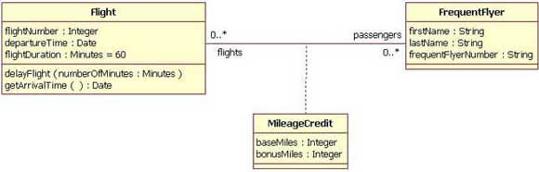

In the class diagram shown in Figure 11, the association between the Flight class and the FrequentFlyer class results in an association class called MileageCredit. This means that when an instance of a Flight class is associated with an instance of a FrequentFlyer class, there will also be an instance of a MileageCredit class.

Aggregation

Aggregation is a special type of association used to model a "whole to its parts" relationship. In basic aggregation relationships, the lifecycle of a *part* class is independent from the *whole* class's lifecycle.

For example, we can think of *Car* as a whole entity and *Car Wheel* as part of the overall Car. The wheel can be created weeks ahead of time, and it can sit in a warehouse before being placed on a car during assembly. In this example, the Wheel class's instance clearly lives independently of the Car class's instance. However, there are times when the *part* class's lifecycle *is not* independent from that of the *whole* class — this is called composition aggregation. Consider, for example, the relationship of a company to its departments. Both *Company and Departments* are modeled as classes, and a department cannot exist before a company exists. Here the Department class's instance is dependent upon the existence of the Company class's instance.

Let's explore basic aggregation and composition aggregation further.

**Basic aggregation**  
An association with an aggregation relationship indicates that one class is a part of another class. In an aggregation relationship, the child class instance can outlive its parent class. To represent an aggregation relationship, you draw a solid line from the parent class to the part class, and draw an unfilled diamond shape on the parent class's association end. Figure 12 shows an example of an aggregation relationship between a Car and a Wheel.

Figure 12. Figure 12: Example of an aggregation association

Example of an aggregation association

**Composition aggregation**  
The composition aggregation relationship is just another form of the aggregation relationship, but the child class's instance lifecycle is dependent on the parent class's instance lifecycle. In Figure 13, which shows a composition relationship between a Company class and a Department class, notice that the composition relationship is drawn like the aggregation relationship, but this time the diamond shape is filled.

Figure 13. Figure 13: Example of a composition relationship

Example of a composition relationship

In the relationship modeled in Figure 13, a Company class instance will always have at least one Department class instance. Because the relationship is a composition relationship, when the Company instance is removed/destroyed, the Department instance is automatically removed/destroyed as well. Another important feature of composition aggregation is that the part class can only be related to one instance of the parent class (e.g. the Company class in our example).